**1. Introduction to ALB Ingress External DNS Install**

--- **note** – in this lesion, we will install externa DNS. Before going and install external DNS. We need to understand that what are the components involved from the external DNS perspective

**Why do we need this external DNS…?**

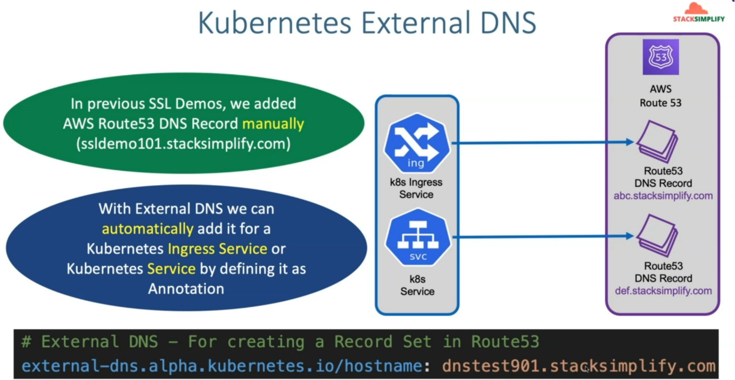

--- if you add your subdomain in ingress service manifest then So, if you add these things, then automatically those records will be added in the AWS Route53 service inside the hosted zone as a DNS record.

--- in addition to that, you can create, update, delete, these DNS records from external DNS itself. So, let's see what all components involved in the external DNS related Controller.

**Components present in external DNS controller**

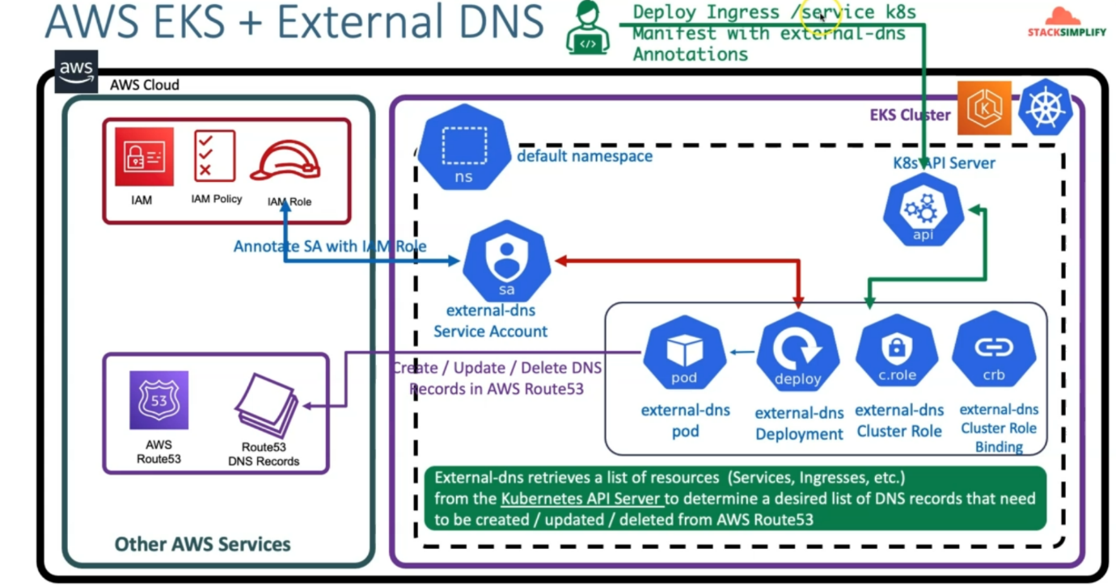

--- in aws cloud, we already have the EKS cluster created, so for external DNS, in the default name space, we are going to create a external DNS service account and this service account will be associated with IAM role.

--- why do we need to create this IAM role? and what is the things present in the IAM policy about permissions that I am policies going to have?

--- So, we are going to create a IAM policy wherein in that I am policy, it will have the permissions for AWS Route53 resource for create, update and then delete records inside of that and that I am policy will be associated with this **IAM** role and that I am role will be annotated in this respect to service account in Kubernetes, which is nothing but external DNS service account and then will also have that external DNS related deployments, cluster role, cluster role bindings, all related objects deployed inside this default namespace.

--- So, this external DNS deployment will create the external DNS pod for us and whenever as a Kubernetes admin, if we deploy Ingress Service or regular Kubernetes service with the annotation, whatever we have specified related to external DNS. So then external DNS goes to the Kubernetes API server and retrieves a list of resources like services or ingresses from the Kubernetes API server to determine a desired list of DNS records that need to be created or updated or deleted from the Route53.

--- So, which means this external DNS pod will communicate with this API server and get a list of the ingress or regular services and search for the annotation related to external DNS with the DNS names. if it finds those DNS names inside those services or ingress services, so then it will go ahead

and then create or update or delete those DNS records in the AWS Route53 related service.